- What is the outcome of this statement
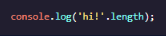

- 1 is printed to the console
- 3 is printed to the console
- ‘hi!’.length will be printed to the console
- hi! Is printed to the console
- What is the correct way to declare a new variable that you can change?
- let myName: ‘Sloan’;
- myName = ‘Sloan’;
- let myName = ‘Sloan’;
- const myName = ‘Sloan’;
- Which of the following code snippets would cause an error?
- 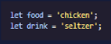
- 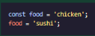
- 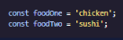
- 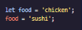

- Which of the following is an example of a single line comments?
- //is this a comment?
- console.log()
- ‘Is this a comment?’
- Console.log(‘Is this a comment?’)
- What will the following code print the console?
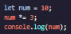
- 30
- 10
- 3
- ‘num’
- What is the string interpolation?
- Print a string to the console.
- Using template literals to embed variables into string.
- Changing the value of a variable.
- Joining multiple strings together using operators like ‘+’
- What is the outcome of the following code snippet?
- Hello world is stored as a variable;
- Hello world is printed to the console;
- log(‘Hello world’) is printed to the console;
- ‘Hello world’ is printed to the console with single quotation marks.
- What are variables used for in JavaScript?
- For changing language settings.
- For changing a value’s data type.
- For storing or holding data.

